World’s Gym
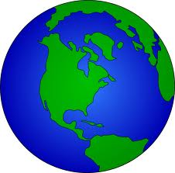
Your Uncle is founding a new gym. It will be called World’s Gym. As the founder, he has lots of responsibility and many, many details to think about. Luckily, he has you to help him out. He knows that you are working on finding the surface area and volume of spheres in your math class, so he turns to you for help! Can you help him??

- Your uncle wants to attract as many customers to his gym as possible. As part of his advertising, he wants to catch people’s eye as they drive by the location of his gym. So, he plans to place a huge sphere (30 feet in diameter) by the entrance. But, he doesn’t know how much paint to buy. What do you need to know to help him?

  - Now, if you know a gallon of paint will cover 400 square feet, how many gallons of paint should he buy in total?

  - But, we know that the Earth is about 70% water and 30% land. He wants to paint the water blue and the land green. So how many gallons of each color of paint should he buy?

- His gym will, obviously, have a basketball gym. So, he needs to buy some cages for all of the balls. He plans to buy basketballs (9 inches in diameter) and dodgeballs (half the diameter of the basketballs).
  - Compute the volume of a basketball and the volume of a dodgeball.

  - Knowing the relationship of the diameters of the two balls, compare their volumes you found in part (a). Can you make a generalization of the pattern? What happens to the volume when you double the radius? Split it in half? You might need to try more examples until you come up with a conjecture.

  - Now, what size cages (in cubic inches) should he buy if he wants to be able to store 25 basketballs in one cage and 25 dodgeballs in a separate cage?

